Join us at West Hyattsville Baptist Church for
Vacation Bible School (VBS)
Classes for All Ages
June 19-23, 2017
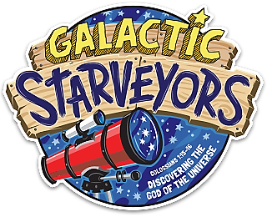

“He is the image of the invisible God, the firstborn over all creation. For everything was created by Him, in heaven and on earth, the visible and the invisible, whether thrones or dominions or rulers or authorities-all things have been created through Him and for Him.” Colossians 1:15-16

West Hyattsville Baptist Church
3100 Nicholson Street
Hyattsville, MD 20782

Rev. Emmett L. Dunn, Pastor

